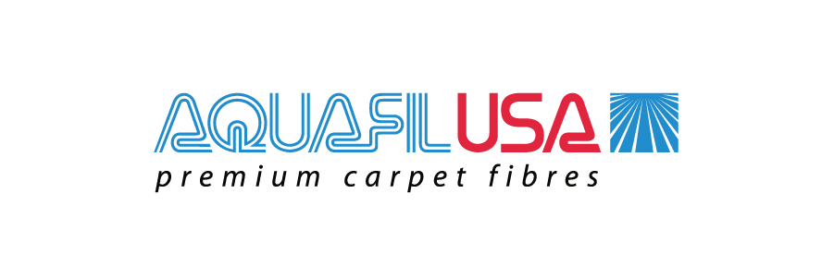

Quality Policy
AQUAFIL USA STRIVES TO BE THE PREFERRED BCF FIBER SUPPLIER IN THE CARPET INDUSTRY.
OUR QUALITY DRIVEN MANAGEMENT SYSTEM IS FOCUSED ON ENHANCING FIBER QUALITY AND COST THROUGH CONTINOUS IMPROVEMENT, EFFICIENCY, AUTOMATION, SUSTAINABILITY, AND INNOVATION.
THE AQUAFIL MANAGEMENT TEAM STRIVES FOR TOTAL STAKEHOLDER SATISFACTION WITH A GOAL OF MEETING ORGANZIATIONAL TARGETS AND CUSTOMER NEEDS.
AQUAFIL USA IS COMMITTED TO USING ROBUST QUALITY PROCESSES TO MAINTAIN THESE ORGANIZATIONAL STANDARDS.

